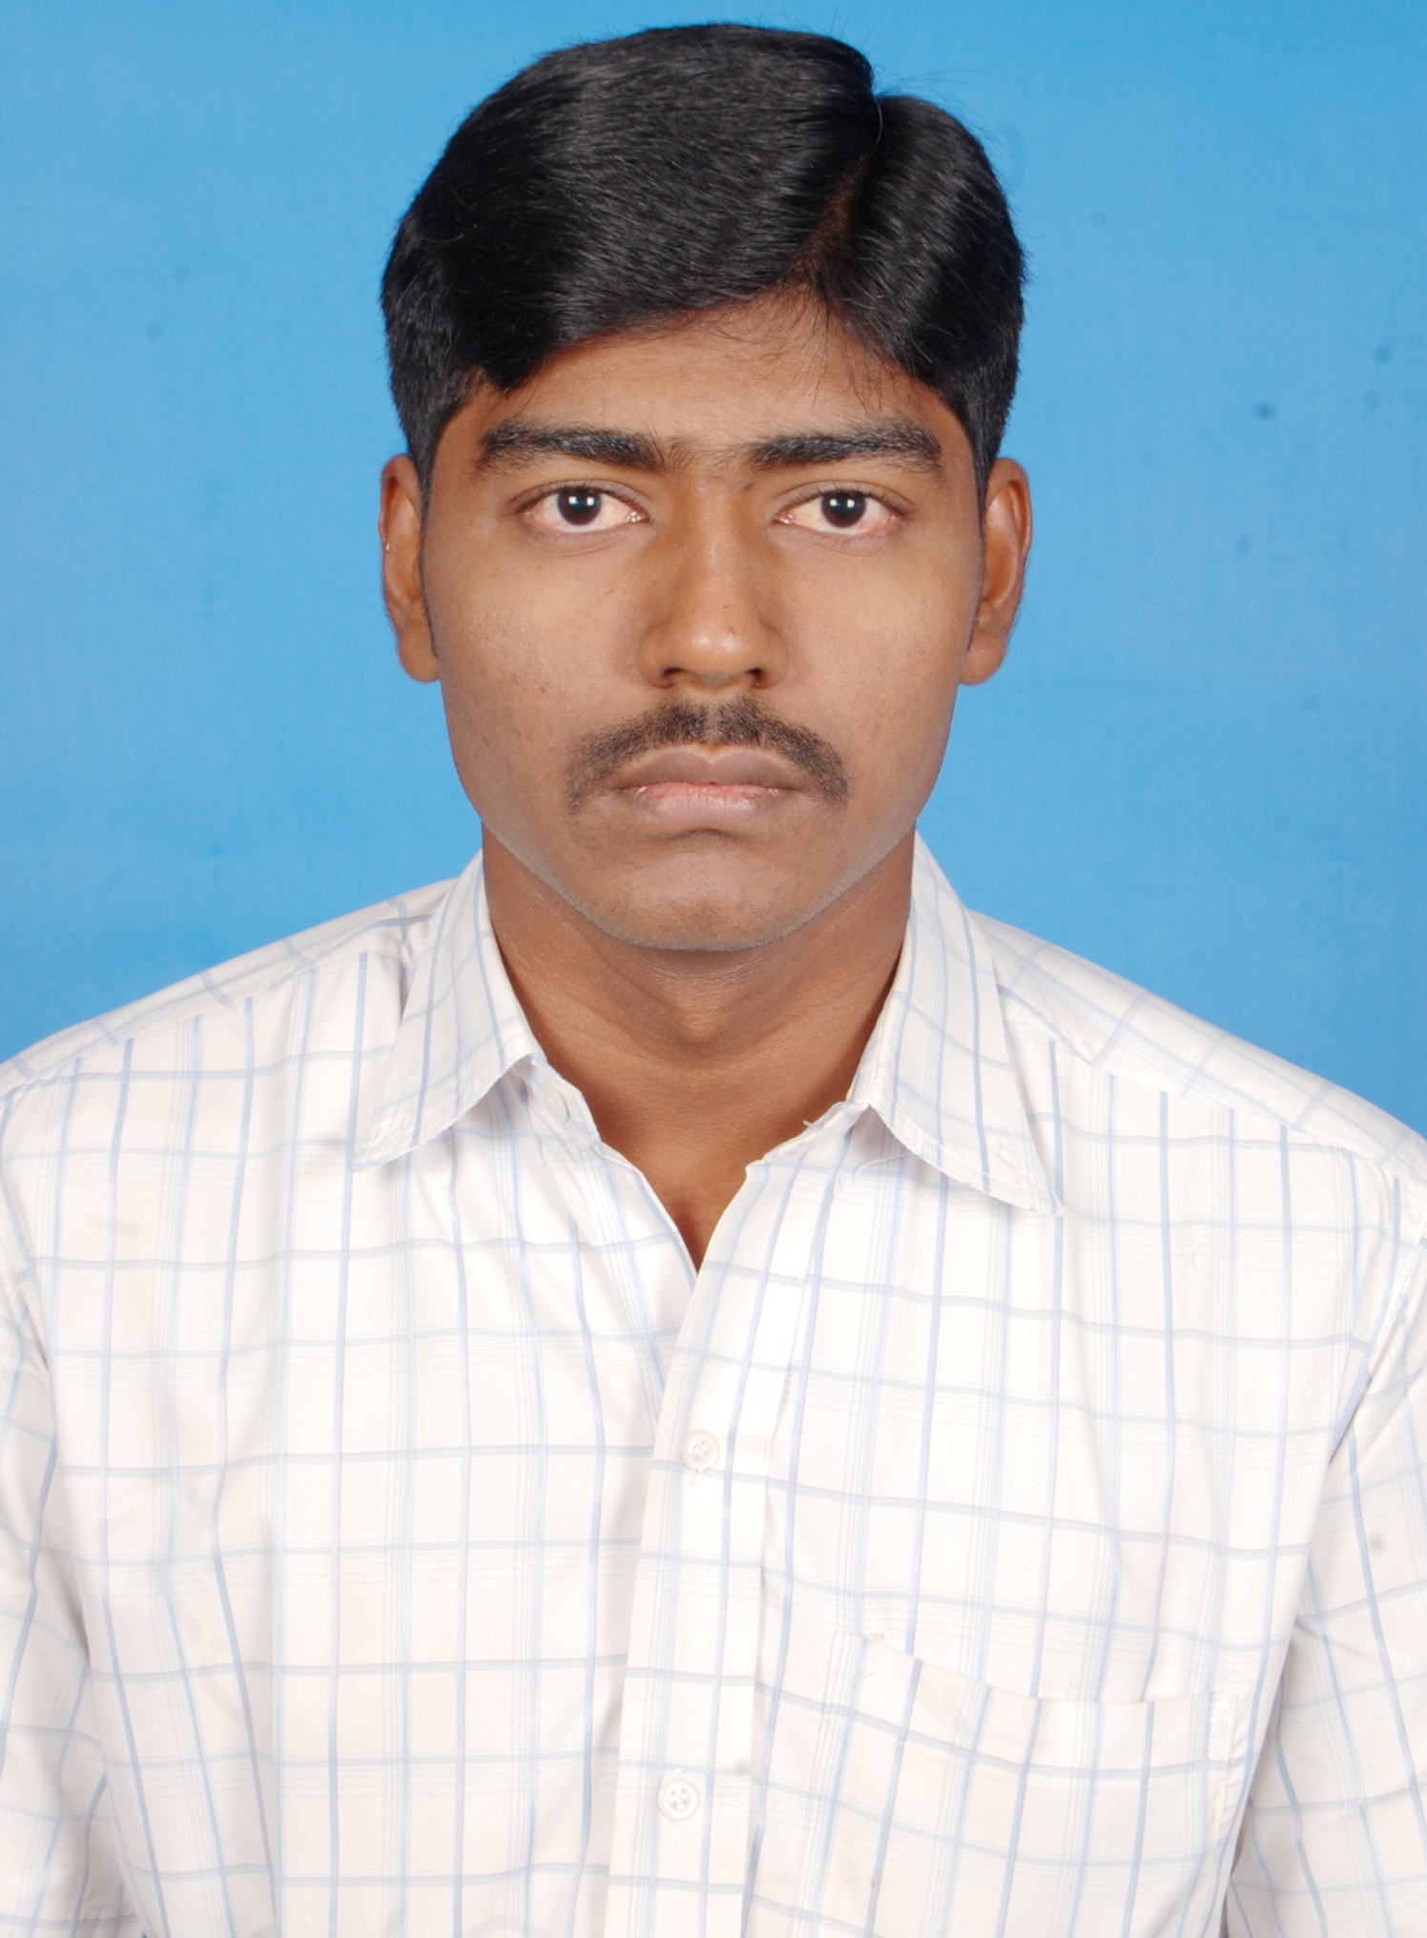
D.S.MOHAN
147/47, Siddi Raja Kandigai (Vill & Post),
Gummidipoondi (TK),
Chennai - 601201.
Tamil Nadu, India.
Mobile No: +91-9629125925
E-Mail: mohansukumar182@gmail.com

CAREER OBJECTIVE:
Seeking a position as a software developer to utilize skills and abilities in the organization for the achievement of personal and corporate goals.
CAREER EXPERIENCE- 2 YEARS 2 Months:
- Currently Working as a Dot Net Developer in BKS Textiles Pvt Ltd, Palladam, from May 2012 [1 Year and 2 Months].
- 1 Year Experience in Convergy IT & Solutions (www.cgits.com), Chennai as DotNet Developer from May 2011 to April 2012.

TECHNICAL SKILLS:

Language Skills : C, C#.NET, LINQ
Operating System : WINDOWS XP, WINDOWS 2007.
Databases : SQL SERVER 2005/2008.
Web Development : HTML, ASP.NET
Tools and Utilities : Visual Studio 2008/2010, MS Expression Blend 4.
Other Applications : Android Programming.

AREA OF INTEREST:

- Website Development.
- Mobile App Development.
- Database Programming.

TRAINING UNDERGONE:

- Soft skills course conducted by INFOSYS CORNERSTONE CONSULTING “CAMPUS CONNECT” from June 28- July 3, 2010.
Skills Honed: Inter-personal skills and importance of Aptitude.

ACADEMIC CREDENTIALS:

Course | Institution | University/ Board | Year of passing | Percentage
B.TECH (Information Technology) | Prathyusha Institute of Technology and Management. | Anna University, Chennai | 2011 | 76
H.S.C | St.Mary’s Matric Hr. Sec. School | Board of Higher Secondary Education | 2007 | 71
S.S.L.C | St.Mary’s Matric Hr. Sec. School | Matriculation | 2005 | 71

INDUSTRY PROJECTS:

Work in BKS Textiles: Website Development and Report generation are the two major jobs allocated for me in BKS Textiles Pvt Ltd, using Asp.Net Application. Along with these Report generations, I also develop Android Application for Loom Planning and Costing.

Convergy Project 1:- Motor Risk Management System (www.motorrisk.com).
Description: Motor Risk Management System (MRMS), is a vehicle insurance management system developed on Asp.Net. The Project was developed for improving quality of technology compared to existing system and to reduce the time taken for life cycle completion process. Processes Involved are Profile Management, Fresh Case, Case Scheduling, Surveyor Allocation, Case Status Updating, Report Uploading, Case Verification, Completion Stage and Bill Generation. Case Stage Updating and Report Uploading are done from Android Mobile application.
Role: Web Page Designing and Code Implementation, Stored Procedure Deployment.
Designation: Software Developer.
Team Size: 6
Technology: C#, ASP.Net, LINQ, Android and SQL Server 2008.

Convergy Project 2:- SMS Filtering
Description: SMS Filtering is a Message Filtering process that was deployed on Asp.Net for a particular consultancy service provider. It was developed as fresh project without any existing project for filtering up the messages based upon the Interest and Qualification of the Client. Processes Involved are Qualification Management, Upload and Download Process, Block and Unblock User, Receive SMS and Auto Reply Message Process. Receive SMS is done from Android Mobile application.
Role: Webpage Designing and Code Implementation, Stored Procedure Deployment.
Designation: Software Developer.
Team Size: 5
Technology: C#, ASP.Net, LINQ, Android and SQL Server 2008.

ACADEMIC PROJECT:
Title: - Detection of Denial of Message Attacks in Wireless Sensor Networks.

RESPONSIBILITIES HELD:
- Organized Face Masking competition for our National Level Technical Symposium.
- Student Sports Coordinator of the college for the year 2009-2010.
- NSS Co-ordinator of the college for the year 2009-2010.

EXTRA CURRICULAR ACTIVITIES:
- Social service (Member of N.S.S)
Participated in AIDS AWARENESS WALK and conducted N.S.S camp.
- Human service (Member of Y.R.C)
Participated in 3 day Orientation programme conducted by Anna University and donated Blood 5 times.

ACHIEVEMENTS:
- Won Runners up in Basketball tournament in Inter-departmental games.
- Won Runners up in Ball Badminton tournament in Inter-departmental games.

PERSONAL DETAILS:

Date of Birth : 04-Aug-1989.
Father’s Name : D.Sukumar.
Mother’s Name : S.Girija.
Nationality : Indian.
Languages Known : English, Tamil, and Telugu.
Marital Status : Single.
Strengths : Optimistic, Flexible, Patience.
Hobbies : Playing Volleyball, Badminton.
Passport No : K4258259.

PLACE : Chennai. AUTHENTICALLY

DATE :



[D S MOHAN]

